# Survey Link: https://goo.gl/forms/ElUp30eEAgCIj6fh1

# Load packages that will be used for the analysis

library(ggplot2)

library(plyr)

library(dplyr)

library(reshape2)

library(plotly)

# Library to install statsr library

library(devtools)

# Install Statsr from github repository

install_github("StatsWithR/statsr")

library(statsr)

# Change the working directory

setwd('C:\\Users\\Abhay\\Desktop\\Business Statistics Project Files\\')

# Load data set

load("193_project_dataset.RData")

#covert the data to tbl_df as they are easier to analyze

shopping_tbl <- tbl_df(shopping)

head(shopping_tbl)

## # A tibble: 6 x 61

## Timestamp Age Gender Marital_Status Education

## <fctr> <fctr> <fctr> <fctr> <fctr>

## 1 9/16/2016 14:20:30 26 to 30 Years Male Single Post Graduate

## 2 9/16/2016 14:21:39 26 to 30 Years Male Single Graduate

## 3 9/16/2016 14:32:17 20 to 25 Years Male Single Graduate

## 4 9/16/2016 15:28:16 20 to 25 Years Male Single Graduate

## 5 9/17/2016 13:49:09 20 to 25 Years Male Single Graduate

## 6 9/22/2016 7:37:54 26 to 30 Years Male Single Graduate

## # ... with 56 more variables: Internet_Access_Device <fctr>,

## # Internet_Browsing_Time_Zone <fctr>, Browsing_Time <fctr>,

## # Working_Time_Zone <fctr>, Working_Hours <fctr>, Felt_Unhappy <fctr>,

## # Felt_Unsatisfied <fctr>, Felt_Cheated <fctr>, Felt_Uneasy <fctr>,

## # Felt_Furious <fctr>, Felt_Made_A_Mistake <fctr>,

## # Felt_Irritated <fctr>, Felt_Disappointed <fctr>,

## # Felt_Frustrated <fctr>, Felt_Concerned <fctr>,

## # Felt_Done_A_Wastage <fctr>, Felt_Anxious <fctr>, Felt_Angry <fctr>,

## # Felt_Negative <fctr>, Thought_Of_Corrective_Action <fctr>,

## # Though_Of_Other_Choice <fctr>, Anxiety_Than_Satisfaction <fctr>,

## # No_Trust <fctr>, Not_Sure_About_Quality <fctr>,

## # Delivery_Of_Same_Product <fctr>, Good_Deal <fctr>,

## # Not_Good_Bargain <fctr>, Cash_Payment_Than_Online_Payment <fctr>,

## # Answer_To_Quesries <fctr>, Info_About_Product <fctr>,

## # Negotiation_For_Better_Deal <fctr>, Customer_Reviews <fctr>,

## # Authenticity_Of_Online_Review <fctr>, Made_A_Wrong_Decision <fctr>,

## # Expectation_Not_Met <fctr>, Buying_From_Same_Retailer <fctr>,

## # Fit_Of_Products <fctr>, Not_Sure_Of_Performance <fctr>,

## # Genuine_Discounts_Or_Not <fctr>, Increase_In_Spam_Mails <fctr>,

## # Selling_Personal_Data <fctr>, Selling_Financial_Data <fctr>,

## # Accurate_Info <fctr>, Keeping_Promise <fctr>,

## # Missing_Personal_Touch <fctr>, Need_Of_Sales_Person <fctr>,

## # Smile_Of_Sales_Person <fctr>, Return_And_Exchange_Policy <fctr>,

## # Painful_Product_Replacemnt <fctr>, Same_Replaced_Product <fctr>,

## # Product_Information <fctr>, Authenticity_Of_Retailers <fctr>,

## # Decoding_Shopping_Pattern <fctr>, Why_Purchase_Online <fctr>,

## # Trail_Of_Product <fctr>, Satisfactory_Experience <fctr>

# Check the summary of dataset for different variables

Summary(shopping_tbl$age)

## 20 to 25 Years 26 to 30 Years

## 0 71 74

## Less than 20 Years More than 30 Years

## 6 11

age_summary <- tbl_df(summary(shopping_tbl$Age))

# Plot a pie chart to represent the various age groups

labels = c('', '20 to 25 Years', '26 to 30 Years', 'Less than 20 Years', 'More than 30 Years')

values = age_summary$value

ds <- data.frame(labels = labels,

values = values)

plot_ly(ds, labels = labels, values = values, type = "pie") %>%

layout(title = "Age Groups of the consumers participating in the survey")

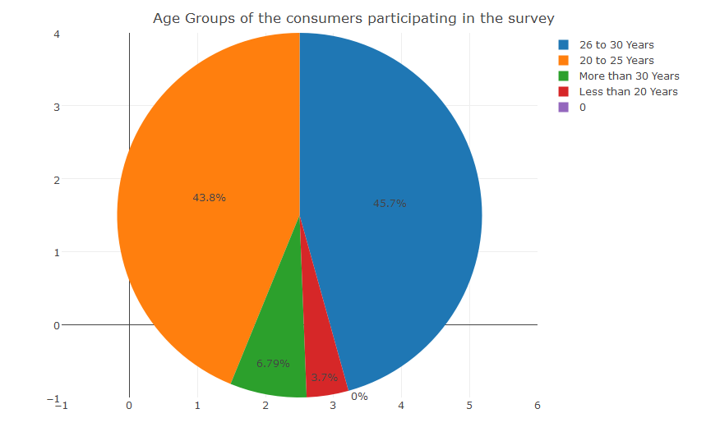

summary(shopping_tbl$Felt_Furious)

# Agree Disagree Neutral Strongly Agree Strongly Disagree

# 0 32 47 64 8 11

# Check for the missing values in the dataset

sum(is.na(shopping_tbl))

# [1] 0

# No missing values in the data set, so we can safely proceed

# This will give us the structure of the categorical variables

str(shopping_tbl$Felt_Unhappy)

# Factor w/ 6 levels "","Agree","Disagree",..: 3 4 2 3 4 3 4 2 3 2 ...

# This gives 6 levels, whereas we have only 5 levels, so we need to remove the extra "" level

for(i in names(shopping_tbl[,3:60])){

shopping_tbl[[i]] <- droplevels(shopping_tbl[[i]])

shopping_tbl[[i]] <- factor(shopping_tbl[[i]], ordered=TRUE)

}

str(shopping_tbl$Felt_Unhappy)

# Assign the correct value to each of the ordinal level

new_levels <- c("1"="Strongly Disagree", "2"="Disagree", "3"="Neutral", "4"="Agree", "5"="StronglyAgree”)

for(i in names(shopping_tbl[,11:60])){

shopping_tbl[[i]] <- revalue(shopping_tbl[[i]], new_levels)

shopping_tbl[[i]] <- ordered(shopping_tbl[[i]], levels=c("Strongly Disagree", "Disagree","Neutral", "Agree","Strongly Agree"))

}

# Check for the structure after removing the "" level

str(shopping_tbl$Felt_Unhappy)

## Ord.factor w/ 5 levels "Strongly Disagree"<..: 2 3 4 2 3 2 3 4 2 4 ...

# Assign the following codes to the ordinal values:

# "1"="Strongly Disagree", "2"="Disagree", "3"="Neutral", "4"="Agree", "5"="Strongly Agree"

for(i in names(shopping_tbl[,11:60])) {

shopping_tbl[[i]] = as.numeric(shopping_tbl[[i]])

}

# Calculate the Online dissonance score

shopping_tbl <- shopping_tbl %>% mutate(Online_Dissonance_Score = Felt_Unhappy + Felt_Made_A_Mistake +

Felt_Done_A_Wastage + Thought_Of_Corrective_Action + Expectation_Not_Met +

Genuine_Discounts_Or_Not + Return_And_Exchange_Policy +

Painful_Product_Replacemnt + Keeping_Promise + No_Trust)

# Calculate the Human interface score

shopping_tbl <- shopping_tbl %>% mutate(Human_Interface_Score = Cash_Payment_Than_Online_Payment +

Negotiation_For_Better_Deal + Missing_Personal_Touch +

Need_Of_Sales_Person + Smile_Of_Sales_Person + Trail_Of_Product )

#Calculate the privacy score

shopping_tbl <- shopping_tbl %>% mutate(Privacy_Score = Increase_In_Spam_Mails + Selling_Personal_Data + Selling_Financial_Data +

Decoding_Shopping_Pattern)

# After adding the three scores, check the table with the new values

head(shopping_tbl[,62:64])

## # A tibble: 6 x 3

## Online_Dissonance_Score Human_Interface_Score Privacy_Score

## <dbl> <dbl> <dbl>

## 1 31 22 14

## 2 30 20 12

## 3 40 24 16

## 4 19 13 9

## 5 29 19 12

## 6 40 23 15

# Check the variation in diffent scores by gender

shopping_tbl_gender <- melt(shopping_tbl, id.vars = "Gender", measure.vars = c("Online_Dissonance_Score","Human_Interface_Score","Privacy_Score"))

# Plot the variation using ggplot

ggplot(data = shopping_tbl_gender, aes(x=variable, y=value)) + geom_boxplot(aes(fill = Gender))

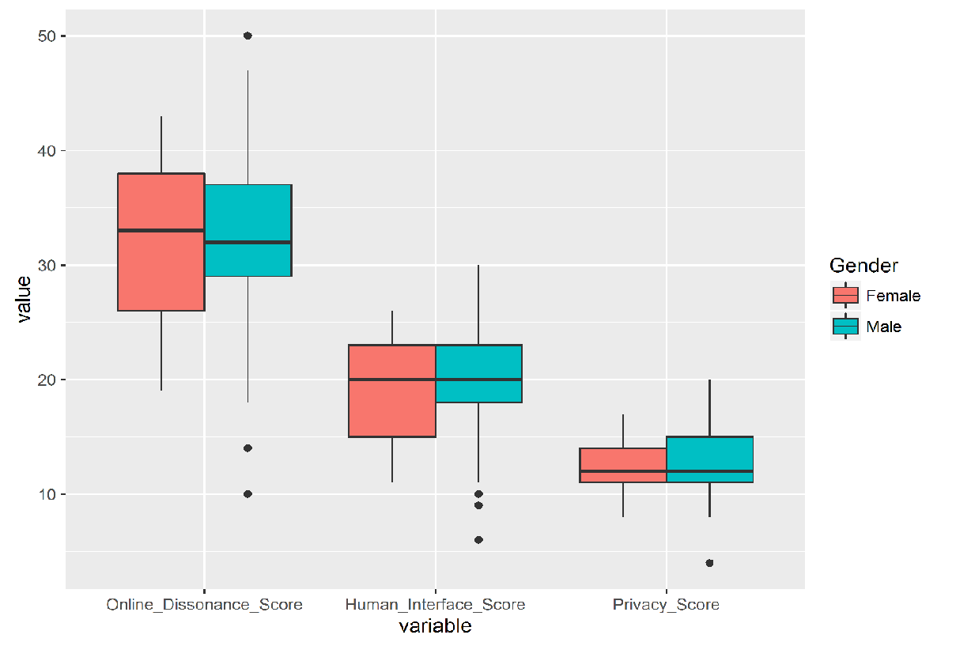

# Take the sample of 80 random observations, setting seed as the last three digits of the person in the group

set.seed(193)

n <- 80

samp <- sample_n(shopping_tbl, n)

## Hypothesis Testing Based on GENDER ##

# Testing hypotheis for Online Dissonance Score based on Gender

inference(y = Online_Dissonance_Score, x = Gender, data = samp, statistic = "mean", type = "ht", null = 0, alternative = "twosided", method = "theoretical")

## Response variable: numerical

## Explanatory variable: categorical (2 levels)

## n_Female = 19, y_bar_Female = 31.7895, s_Female = 7.5098

## n_Male = 61, y_bar_Male = 31.9836, s_Male = 7.2284

## H0: mu_Female = mu_Male

## HA: mu_Female != mu_Male

## t = -0.0993, df = 18

## p_value = 0.922

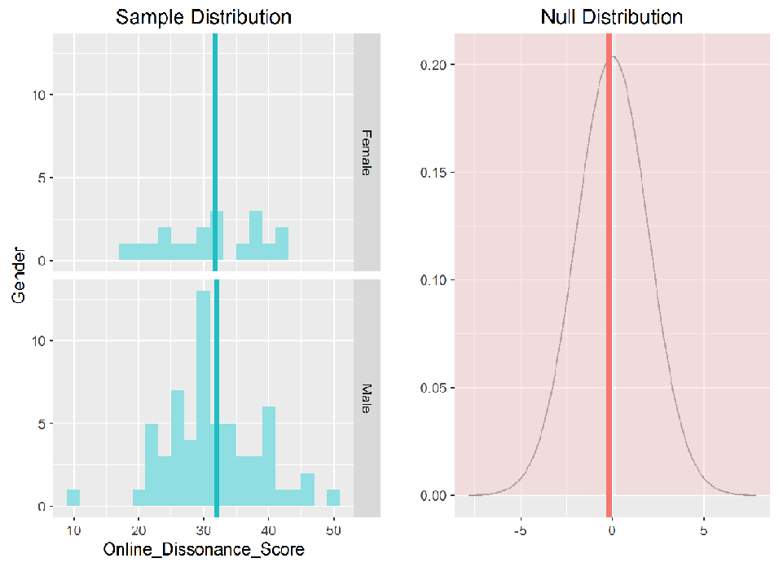

# Testing hypotheis for Human Interface Score based on Gender

inference(y = Human_Interface_Score, x = Gender, data = samp, statistic = "mean", type = "ht", null = 0, alternative = "twosided", method = "theoretical")

## Response variable: numerical

## Explanatory variable: categorical (2 levels)

## n_Female = 19, y_bar_Female = 18.4737, s_Female = 4.8117

## n_Male = 61, y_bar_Male = 19.8525, s_Male = 4.3468

## H0: mu_Female = mu_Male

## HA: mu_Female != mu_Male

## t = -1.1153, df = 18

## p_value = 0.2794

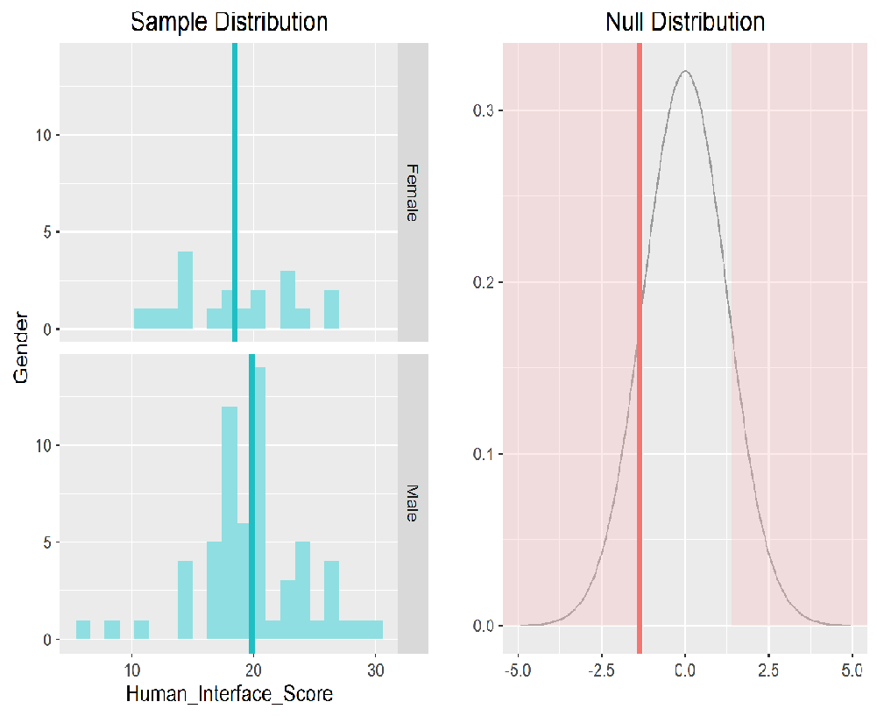

# Testing hypotheis for Privacy Score based on Gender

inference(y = Privacy_Score, x = Gender, data = samp, statistic = "mean", type = "ht", null = 0, alternative = "twosided", method = "theoretical")

## Response variable: numerical

## Explanatory variable: categorical (2 levels)

## n_Female = 19, y_bar_Female = 12.6842, s_Female = 2.4732

## n_Male = 61, y_bar_Male = 12.9344, s_Male = 2.886

## H0: mu_Female = mu_Male

## HA: mu_Female != mu_Male

## t = -0.3695, df = 18

## p_value = 0.716

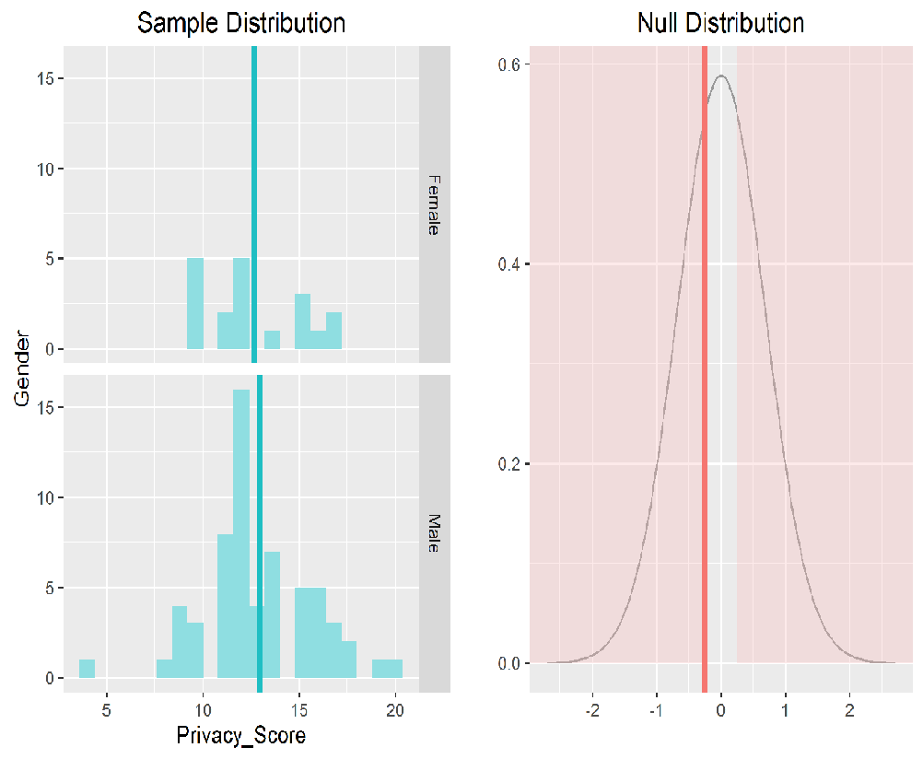

## Hypotheis Testing based on MARITAL STATUS ##

removing_single_again <- filter(shopping_tbl, Marital_Status != "Single Again")

shopping_tbl_marital_status <- melt(removing_single_again, id.vars = "Marital_Status", measure.vars = c("Online_Dissonance_Score","Human_Interface_Score","Privacy_Score"))

ggplot(data = shopping_tbl_marital_status, aes(x=variable, y=value)) + geom_boxplot(aes(fill = Marital_Status))

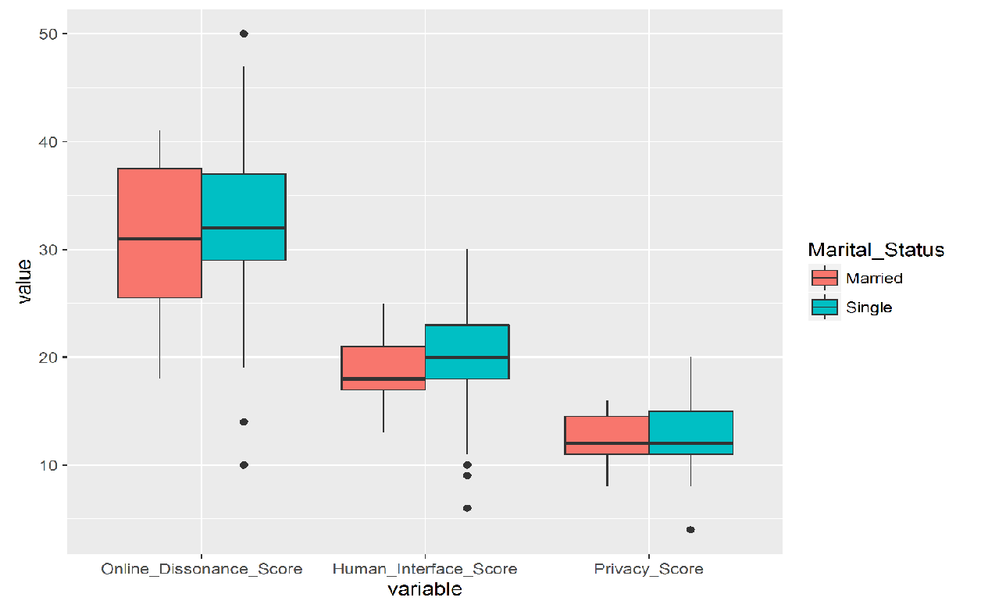

# Removing 'Single Again' level from the dataset

removing_single_again[["Marital_Status"]] <- droplevels(removing_single_again[["Marital_Status"]])

removing_single_again[["Marital_Status"]] <- factor(removing_single_again[["Marital_Status"]], ordered = TRUE)

# Taking a different seed here than our previous sample because that might contain data for `single again` level of Marital_Status variable,

# which we are to exclude from our analysis.

set.seed(194)

n <- 80

samp_marital_status <- sample_n(removing_single_again, n)

# Testing for Online Dissonance based on Marital Status

inference(y = Online_Dissonance_Score, x = Marital_Status, data = samp_marital_status, statistic = "mean", type = "ht", null = 0, alternative = "twosided", method = "theoretical")

## Response variable: numerical

## Explanatory variable: categorical (2 levels)

## n_Married = 14, y_bar_Married = 33, s_Married = 6.4807

## n_Single = 66, y_bar_Single = 33.1667, s_Single = 6.9362

## H0: mu_Married = mu_Single

## HA: mu_Married != mu_Single

## t = -0.0863, df = 13

## p_value = 0.9325

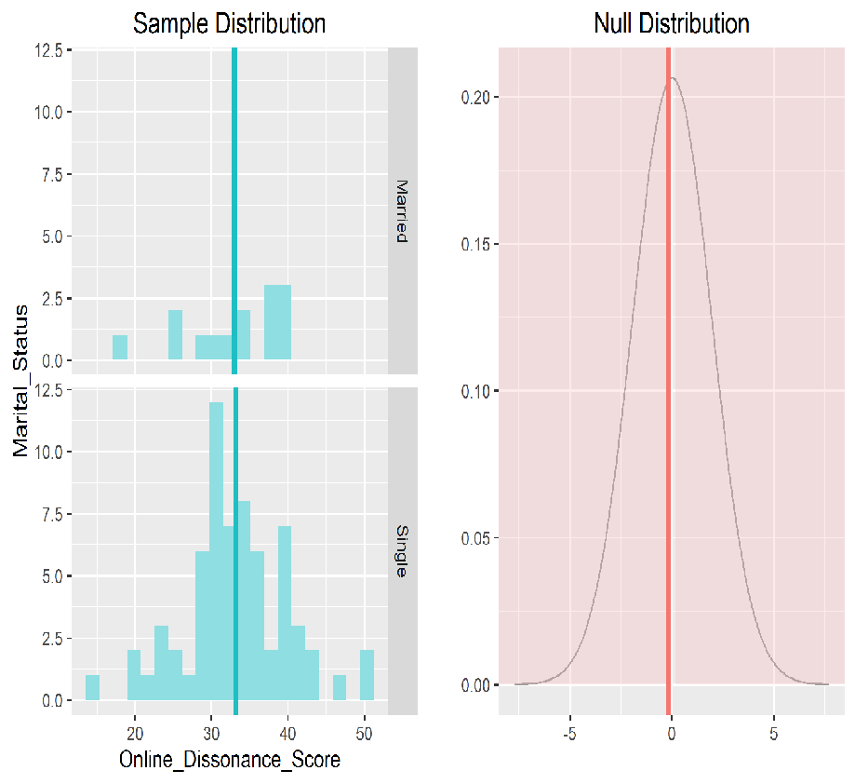

# Testing for Human Interface based on Marital Status

inference(y = Human_Interface_Score, x = Marital_Status, data = samp_marital_status, statistic = "mean", type = "ht", null = 0, alternative = "twosided", method = "theoretical")

## Response variable: numerical

## Explanatory variable: categorical (2 levels)

## n_Married = 14, y_bar_Married = 19.4286, s_Married = 2.7932

## n_Single = 66, y_bar_Single = 20.1212, s_Single = 4.3695

## H0: mu_Married = mu_Single

## HA: mu_Married != mu_Single

## t = -0.7528, df = 13

## p_value = 0.465

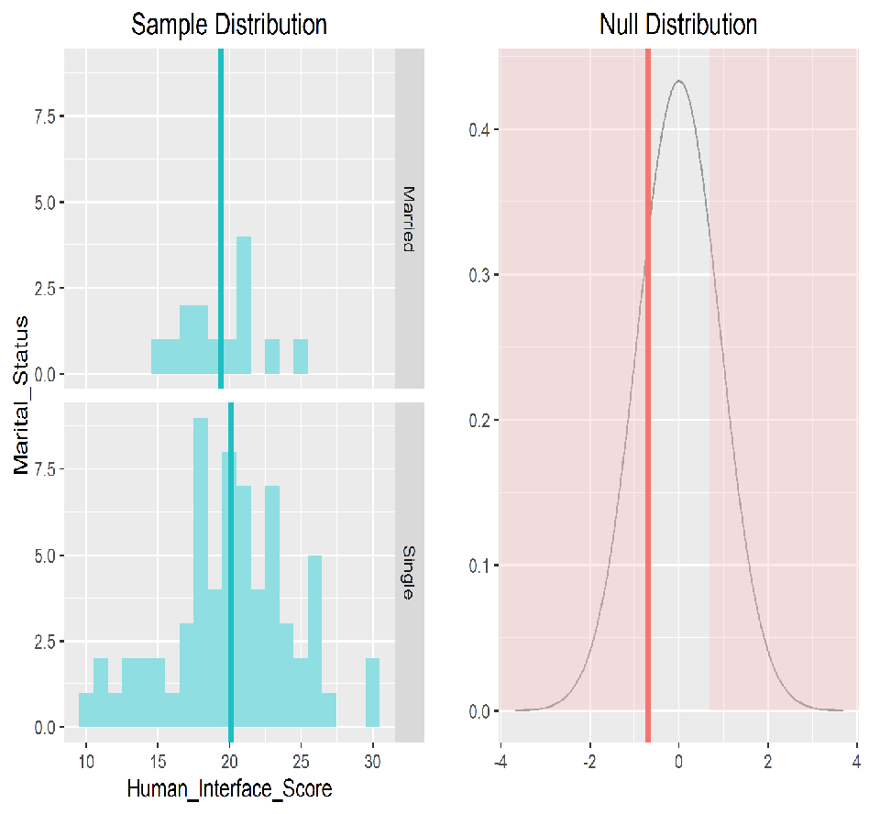

# Testing for Privacy based on Marital Status

inference(y = Privacy_Score, x = Marital_Status, data = samp_marital_status, statistic = "mean", type = "ht", null = 0, alternative = "twosided", method = "theoretical")

## Response variable: numerical

## Explanatory variable: categorical (2 levels)

## n_Married = 14, y_bar_Married = 12.7857, s_Married = 2.1187

## n_Single = 66, y_bar_Single = 13.0758, s_Single = 2.5499

## H0: mu_Married = mu_Single

## HA: mu_Married != mu_Single

## t = -0.448, df = 13

## p_value = 0.6615

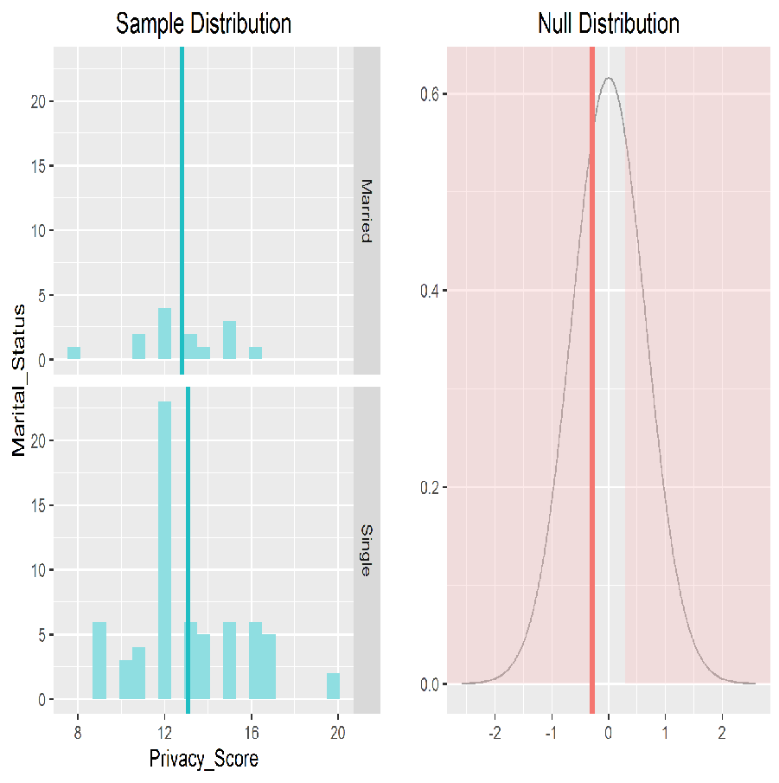

## Hypothesis testing based on EDUCATION ##

shopping_tbl_education <- melt(shopping_tbl, id.vars = "Education", measure.vars = c("Online_Dissonance_Score","Human_Interface_Score","Privacy_Score"))

ggplot(data = shopping_tbl_education, aes(x=variable, y=value)) + geom_boxplot(aes(fill = Education))

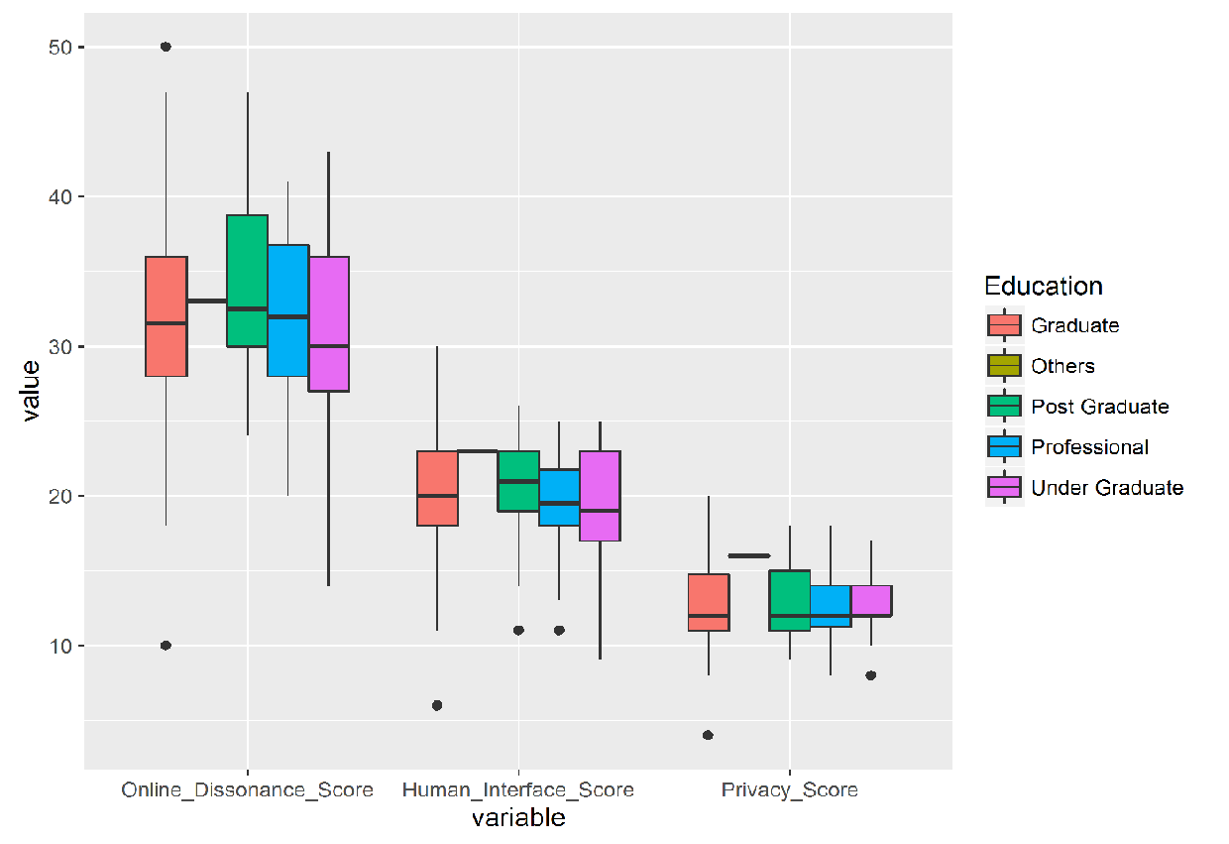

# Testing for online Dissonance based on Education

inference(y = Online_Dissonance_Score, x = Education, data = samp, statistic = "mean", type = "ht", null = 0, alternative = "greater", method = "theoretical")

## Response variable: numerical

## Explanatory variable: categorical (5 levels)

## n_Graduate = 25, y_bar_Graduate = 31.52, s_Graduate = 8.8182

## n_Others = NA, y_bar_Others = NA, s_Others = NA

## n_Post Graduate = 23, y_bar_Post Graduate = 33.6957, s_Post Graduate = 6.4062

## n_Professional = 19, y_bar_Professional = 31.9474, s_Professional = 6.0962

## n_Under Graduate = 13, y_bar_Under Graduate = 29.6154, s_Under Graduate = 6.8743

##

## ANOVA:

## df Sum_Sq Mean_Sq F p_value

## Education 3 145.5536 48.5179 0.9207 0.435

## Residuals 76 4005.1339 52.6991

## Total 79 4150.6875

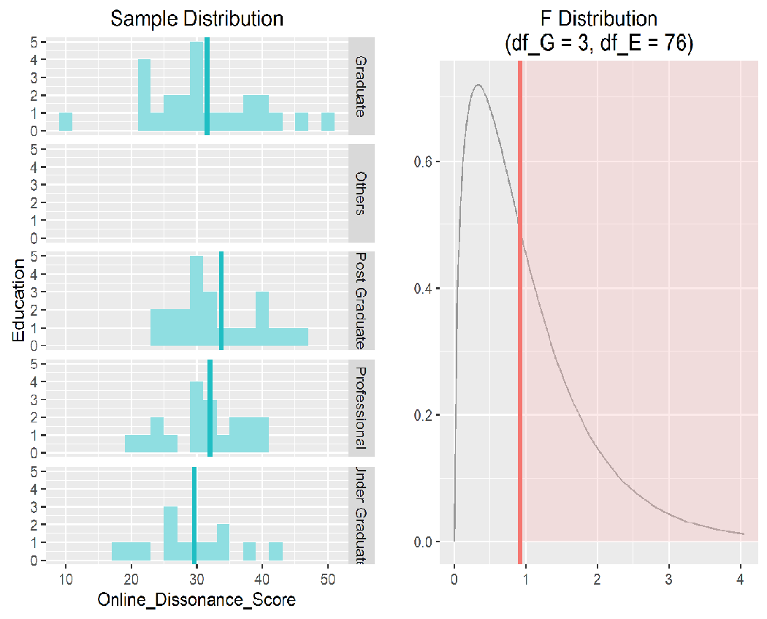

# Testing for Human Interface based on Education

inference(y = Human_Interface_Score, x = Education, data = samp, statistic = "mean", type = "ht", null = 0, alternative = "greater", method = "theoretical")

## Response variable: numerical

## Explanatory variable: categorical (5 levels)

## n_Graduate = 25, y_bar_Graduate = 19.72, s_Graduate = 5.6163

## n_Others = NA, y_bar_Others = NA, s_Others = NA

## n_Post Graduate = 23, y_bar_Post Graduate = 20.3913, s_Post Graduate = 3.5128

## n_Professional = 19, y_bar_Professional = 19.7895, s_Professional = 3.7354

## n_Under Graduate = 13, y_bar_Under Graduate = 17.2308, s_Under Graduate = 4.1864

##

## ANOVA:

## df Sum_Sq Mean_Sq F p_value

## Education 3 87.9662 29.3221 1.4956 0.2225

## Residuals 76 1489.9838 19.6051

## Total 79 1577.95

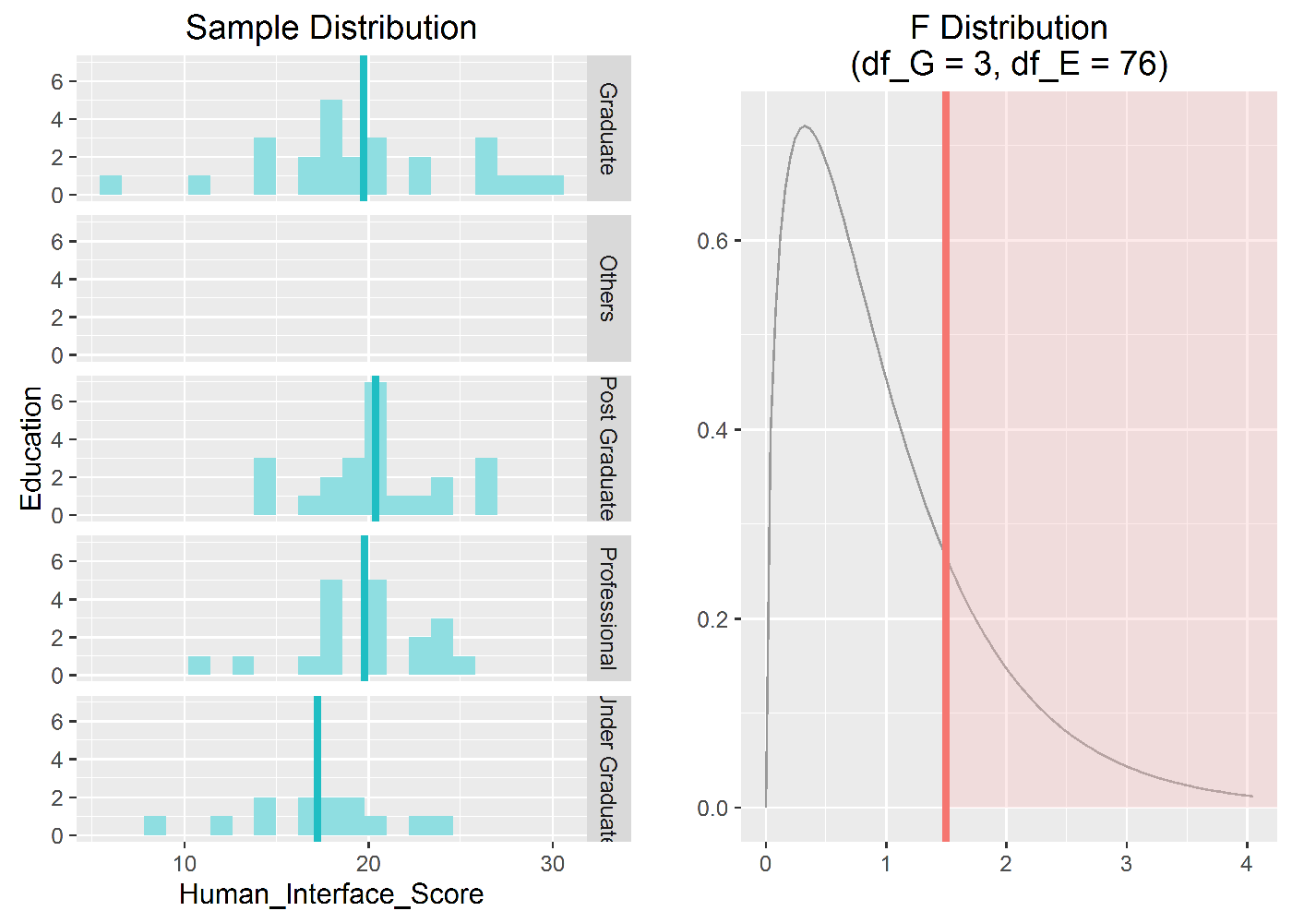

# Testing for Privacy based on Education

inference(y = Privacy_Score, x = Education, data = samp, statistic = "mean", type = "ht", null = 0, alternative = "greater", method = "theoretical")

## Response variable: numerical

## Explanatory variable: categorical (5 levels)

## n_Graduate = 25, y_bar_Graduate = 12.96, s_Graduate = 3.4215

## n_Others = NA, y_bar_Others = NA, s_Others = NA

## n_Post Graduate = 23, y_bar_Post Graduate = 12.913, s_Post Graduate = 2.8109

## n_Professional = 19, y_bar_Professional = 13.1579, s_Professional = 2.3157

## n_Under Graduate = 13, y_bar_Under Graduate = 12.2308, s_Under Graduate = 2.0878

##

## ANOVA:

## df Sum_Sq Mean_Sq F p_value

## Education 3 7.1299 2.3766 0.2992 0.8258

## Residuals 76 603.6201 7.9424

## Total 79 610.75

